RESUME

ASWATHY SURENDRAN K  Kalathiparambil house  Iranikkulam P.O,  Thirumukkulam.  Thrissur  Pin :680734 | 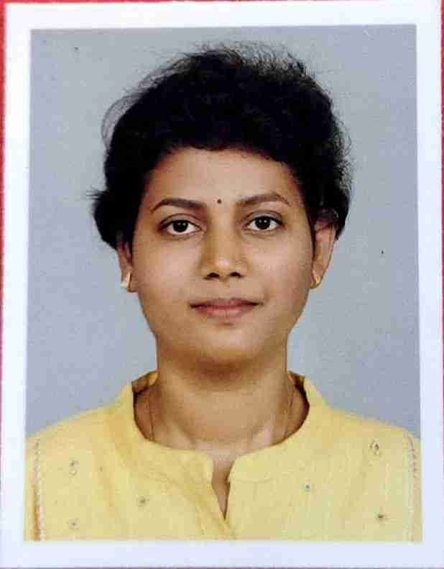  Aswathysurendran.k@gmail.com  Mobile: 9847006133

CARRIER OBJECTIVES:

To establish myself in the field of research and execution .Utilize my skills and experience to conserve green nature ,resources and facilitate peoples to improve their knowledge about the importance of conservation .

EDUCATIONAL QUALIFICATION:

- Pursuing P.hd at S N College, Nattika, Thrissur
- M.Sc.Botany: at St.Teresa’s college, Ernakulam under Mahatma Gandhi University with 71 % of mark(2012-2014)
- B.Sc Botany: at Carmel College Mala, Thrissur under Calicut University with 89% of mark(2009-2012)
- PLUS TWO: at Viveka Chandrika Sabha Higher Secondary School Puthenvelikara Ernakulam under Higher Secondary Board Of Examination Kerala, with 76% of mark (2007-2009)
- SSLC: at Government Higher Secondary School Iranikkulam, Thrissur, , with 77% of mark (2007) .

WORK EXPERIENCE:

- Currently working at S N College Nattika.
- Worked as Assistant Professor on Contract during the period from 2015 to 2017 at Carmel College , Mala Thrissur.
- NSS Programme Officer at Carmel College ,Mala during 2016 -2017.
- SSP Faculty Member at Carmel College ,Mala during 2015 -2017.
- Worked as Tissue culture lab assistant at Carmel College ,Mala.
- Experienced in supervising dissertations for UG & PG students.

EXPERTISE AND SKILLS:
- Outstanding ability to handle syllabus at the undergraduate and graduate curriculum.
- Remarkable ability to teach, inspire and develop young people .
- Strong organizational skills and proficient with MS office tools .
- Proficient in using audio-visual teaching methods.
- Ability to speak and write Malayalam, English, & Hindi, with considerable command, written as well as verbal.
- Proficient in laboratory teaching

PERSONAL INTERESTS:

- Reading books and journals based on Bio Science
- Traveling
- Drawing
- Dance
- Music
- Gardening

AWARDS/ACHIEVEMENTS/CERTIFICATIONS

- Qualified in CSIR/ UGC National Eligibility Test conducted on December 2017.
- Paper Presentation in National workshop conducted by Devaswom board Pampa College, Parumala,Pathanamthitta.InAssociation with Kerala State biodiversity Board.february 2025.
- Paper Presentation in National workshop conducted by Sree Narayana college Nattika 30 january 2025.
- Book chapter publication in Medicinal Plants and their Bioactive Compounds in Human Health: Volume 1(ISBN 978-981-97-6894-3 ISBN 978-981-97-6895-0) ,Springer Nature ,2024.
- Paper Presented in National Conference on Phytomedicine organized by Department of Botany, Bharathiar University Coimbatore during January 2023.
- Paper publication in IJSER,2019 on the topic “ Taxonomical ,Phytochemical And Pharmacognostic Studies In An Endemic Aroid .
- Participated Poster presentation in the National seminar on “Biodiversity Utilization & Management For Natural Harmony” at Govt.College,Pullut ,Thrissur, by government of Kerala.
- Powerpoint presentation in International conference “ Trends and Innovations in Science Arts and Commerce “ at St.Mary’s College,Thrissur, 2019, organized by Marian Centre for Advanced Research.
- Received Best Science Research Paper Award in connection with National Science Day -2016 conducted by Department of Botany, Carmel College,Mala.
- Secured 3rd place in Women Cricket in the Calicut University Inter Zonal held at Calicut University During 2010-2011
- Advanced Diploma in Tissue Culture with A grde (Carmel college Mala, Thrissur, under Calicut University)
- Certificate course in Tissue Culture with 88% of mark(Carmel College mala Thrissur, under Calicut University)
- Academic Excellence Gold Medal winner for Best Student in Botany Department,2012
- Winner in various arts and sports competitions at school & college level.
- Third place in Sanghanitham, A grade in Folk Dance competition at Sub District level.

EXTRA CURRICULAR ACTIVITIES
- College Union member during 2008-2009
- Actively participated in various National seminars & science exhibitions.
- Passed C – certificate held 2011 under the authority of Ministry of Defence,Government of India
- Active member of NCC & CSS (2009-2012)
- Sports
- Dance
- Music
COMPUTER SKILL

Operating System : WINDOWS 98/2000/XP, WINDOWS 7, Vista

Word processing : MS Office

PERSONAL PROFILE

Age : 28
Date of Birth : 31/05/1992
Father’s Name : K K Surendran
Mother’s Name : Shiby Surendran
Sex : Female
Marital Status : Married
Religion : Hindu
Nationality : Indian

Declaration:

I hereby declare that the information furnished above is true to the best of my knowledge.

Place : Thirumukkalam  Date : 25/06/2020 | ASWATHY SURENDRAN K

