**REPORT**

**Prof. C V Sudhi Memorial Lecture**

**Event:** Prof. C. V. Sudhi Memorial Lecture

**Host:** Department of Chemistry, Sree Narayana College, Nattika

**Date & Time:** August 25, 2025, 10:00 AM - 1:00 PM

**Venue:** Seminar Hall, Sree Narayana College, Nattika

**Topic:** 'Molecular Systems in Artificial Photosynthesis'

**Resource Person:** Dr. Sebastian Nybin Remello, Assistant Professor, Department of Applied Chemistry, CUSAT, Kerala

**Attendance:** 70 Students (from Chemistry, Botany, and Zoology Departments)

The Department of Chemistry at Sree Narayana College, Nattika, successfully organized the **Prof. C. V. Sudhi Memorial Lecture** on August 25, 2025. The event was a tribute to the late Prof. C. V. Sudhi and aimed to enrich the academic environment with cutting-edge research in chemical science. The lecture, delivered by **Dr. Sebastian Nybin Remello** from CUSAT, was centered on the topic: **'Molecular Systems in Artificial Photosynthesis'**.

Dr. Remello provided a comprehensive and engaging presentation on the principles, challenges, and advancements in designing molecular systems that mimic natural photosynthesis to convert sunlight into storable energy, primarily in the form of fuels like hydrogen. He elucidated the crucial role of transition metal complexes, chromophores, and catalysts in creating efficient artificial photosynthetic devices. The talk was structured to be accessible to a diverse student audience, bridging complex chemical concepts with real-world applications in sustainable energy.

The program saw a strong attendance of **70 students**, including participants from the **Chemistry**, **Botany**, and **Zoology** departments. This interdisciplinary mix significantly enhanced the session.

Following the formal presentation, an extensive **interactive session** was held. Students actively engaged with Dr. Remello, posing questions that spanned the chemical mechanisms, biological relevance (comparing natural vs. artificial photosynthesis), and future engineering prospects of the technology. The presence of students from life science disciplines, such as Botany and Zoology, led to a richer discussion on bio-inspiration and the environmental impact of these solar fuel systems. The resource person effectively addressed the diverse queries, ensuring clarity across all fields of inquiry.

The Prof. C. V. Sudhi Memorial Lecture served as a highly **motivational** and academically enriching event, particularly due to its interdisciplinary nature. The talk successfully **motivated** the students by showcasing a frontier research area with significant global relevance (clean energy). The clarity and enthusiasm of Dr. Remello instilled a sense of excitement and possibility regarding scientific careers.The programme's greatest outcome was fostering **interdisciplinary appreciation** among students. Chemistry students gained a broader context for their subject's application in energy and its connection to biological processes. Botany and Zoology students, in turn, were exposed to the molecular engineering and synthetic chemistry principles behind mimicking the process they study in nature. Students were directly exposed to the methodology and challenges of **applied chemical research**, moving beyond textbook theory to understand real-world scientific problem-solving. The lecture served as a crucial platform for **integrating concepts** from photochemistry, catalytic science, and energy technology, demonstrating how different scientific fields must converge to solve global challenges like climate change and energy scarcity.

The lecture successfully honored the memory of Prof. C. V. Sudhi by promoting advanced scientific discourse and intellectual exchange across departments.

**Brochure and photos:**

|  |
| --- |
| **C:\Users\Nithin\Desktop\C. V sudhi memorial lecture 2025.png** |

|  |  |
| --- | --- |
| **C:\Users\Nithin\Desktop\c v sudhi8.jpg** | **C:\Users\Nithin\Desktop\c v sudhi 7.jpg** |
| **C:\Users\Nithin\Desktop\c v sudhi6.jpg** | **C:\Users\Nithin\Desktop\c v sudhi 5.jpg** |
| **C:\Users\Nithin\Desktop\c v sudhi 2.jpg** | **C:\Users\Nithin\Desktop\cv sudhi 3.jpg** |

**Feedback:**

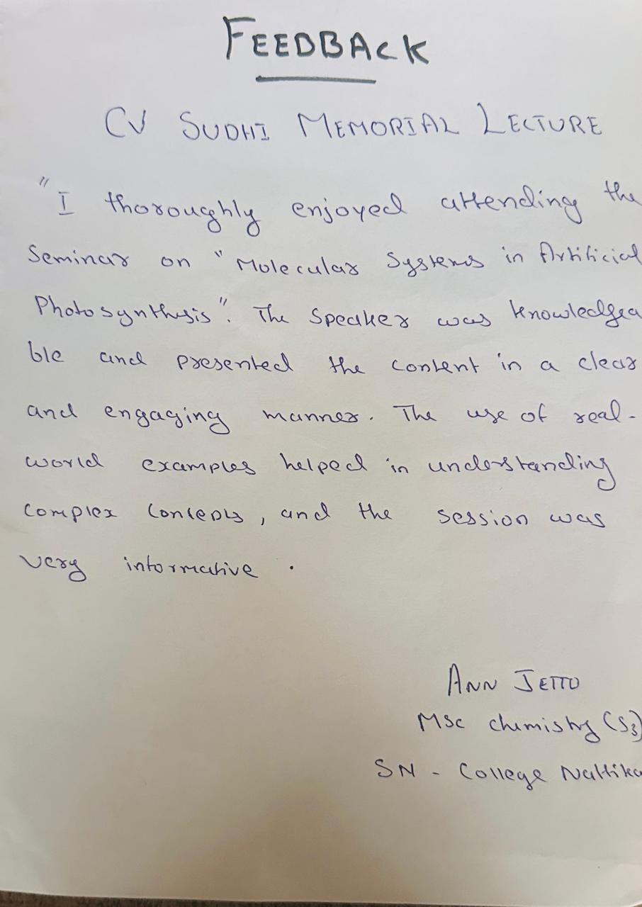

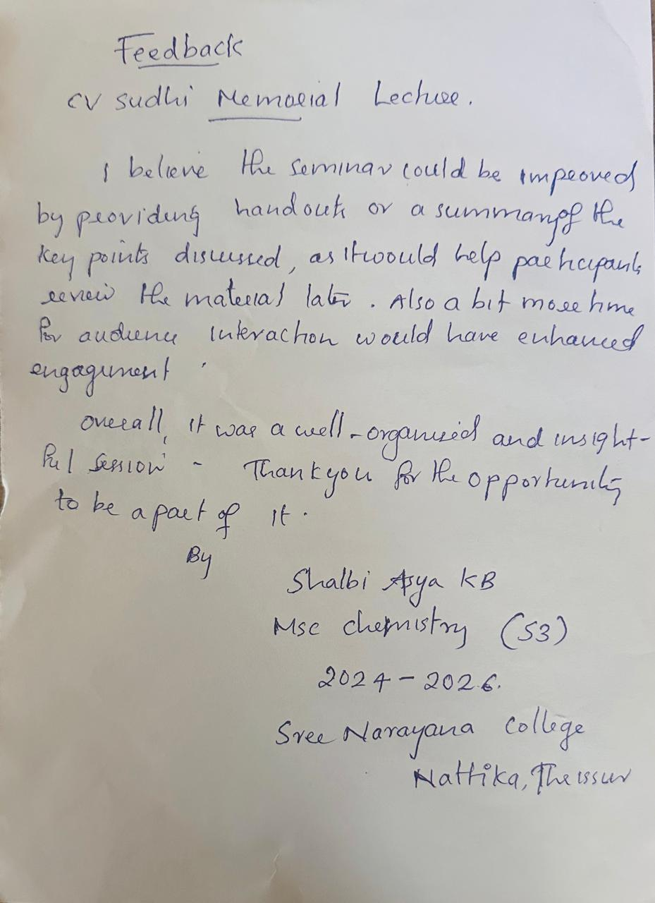

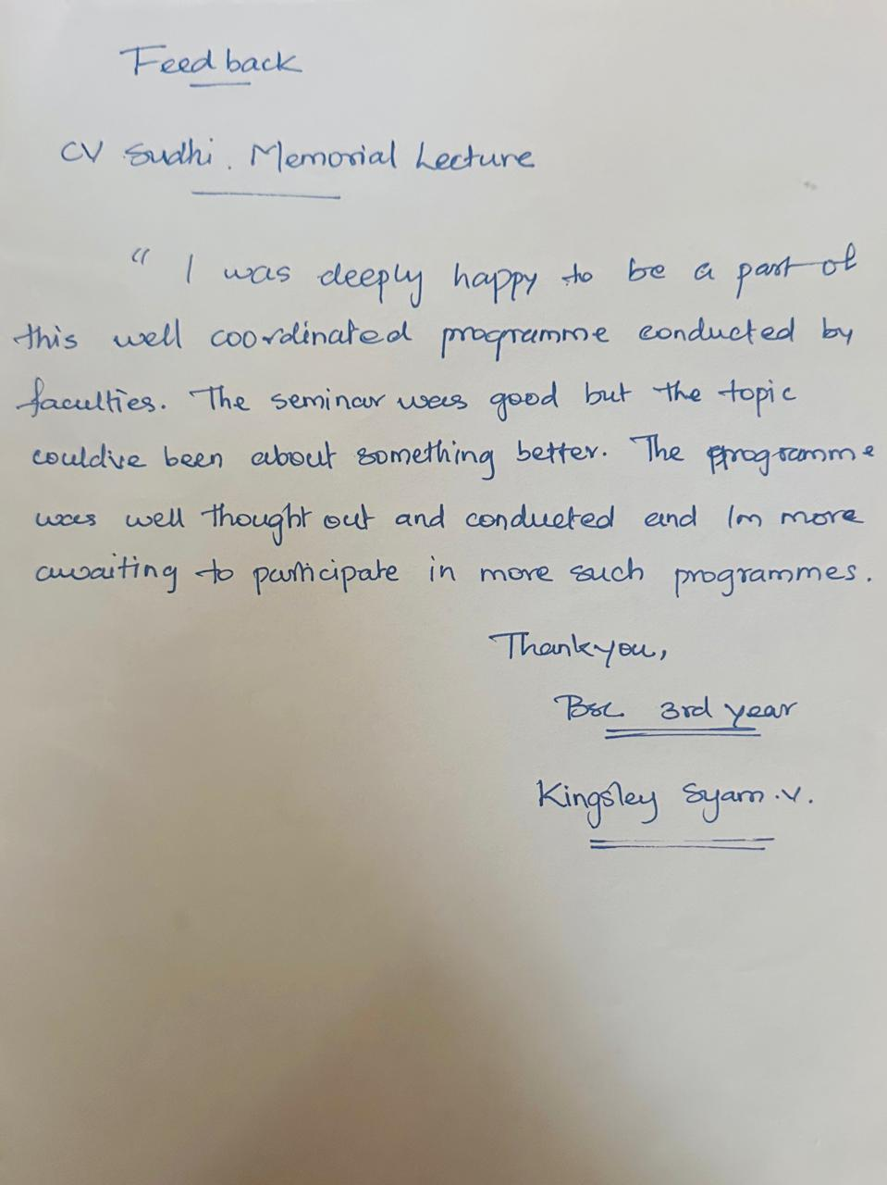

**List of participants:**

**<https://drive.google.com/file/d/1gV3dokBn_Z0YYY_8awSc-S8tQ8AvtnI6/view?usp=sharing>**